*[Install Apache Cassandra on Windows](http://developertutorials.net/cassandra/setting-up-apache-cassandra-on-windows7/) 7*

This post will explain the steps to install Apache Cassandra on a windows computer.As mentioned in the previous post the opensource version of Cassandra is the Apache Cassandra.

Files Required for Installation:

1. Latest release of Apache Cassandra.
2. Java development kit 1.8
3. Python 2.7

Step 1:

Download the latest release of Apache Cassandra. navigate to Downloads page of Apache Cassandra [here](http://cassandra.apache.org/download/).  And download the latest release.

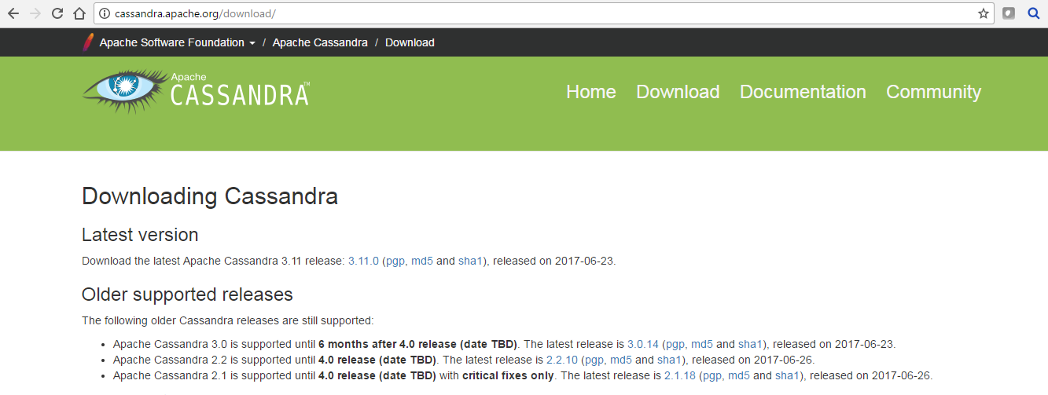

cassandra download

Now extract the downloaded file to a folder in your computer. say C:\Cassandra

[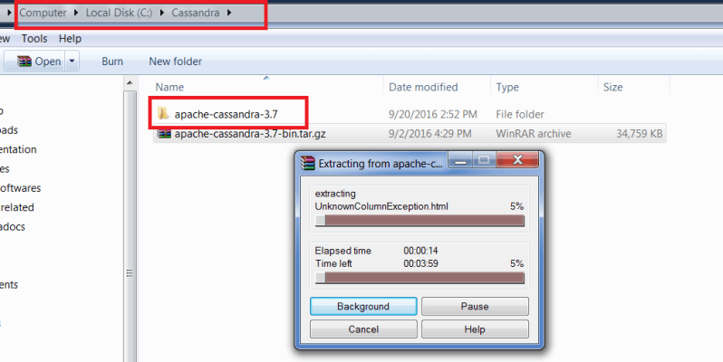](https://i1.wp.com/developertutorials.net/wp-content/uploads/2016/09/cassandra-file.png)

Step 2:

Download and install JDK 1.8 from the oracle downloads page [here](http://www.oracle.com/technetwork/java/javase/downloads/jdk8-downloads-2133151.html) .

Step 3:

Download and install Python 2.7 from [here](https://www.python.org/download/releases/2.7/).

*Cassandra CQl is a python based utility and it has issues with other versions of python.Hence use version 2.7*

Step 4:

Make changes to the configuration files.Navigate to

*<Cassandra_folder>\apache-cassandra-3.7\bin*

Open Cassandra.bat in a notepad and edit the same.Add below line to the same

*set Java_home= <path to JDK 1.8>*

[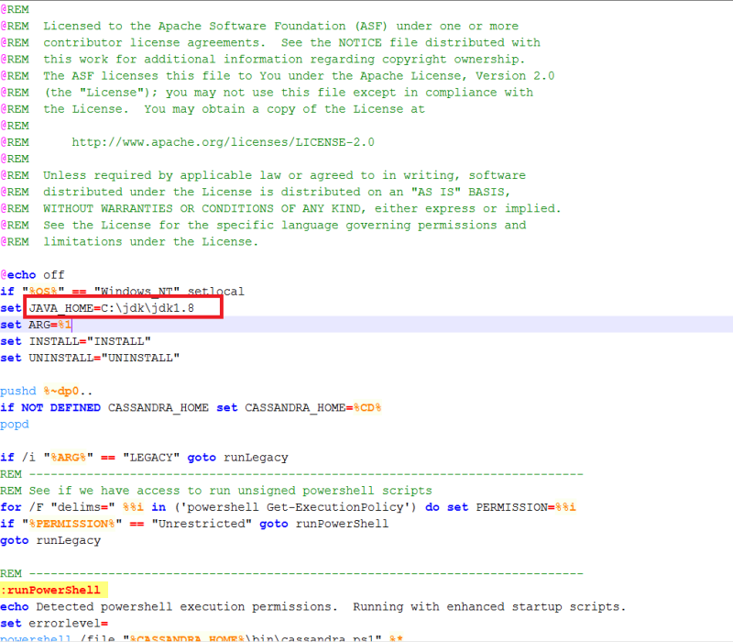](https://i2.wp.com/developertutorials.net/wp-content/uploads/2016/09/cassandra-bat-file.png)

editing java_home in cassandra.bat file

Search for the text ‘JAVA_OPTS’ and change the java memory opts. Initially it will be set to 2G.You can change it to 512M or 1G whichever is fine for you.

[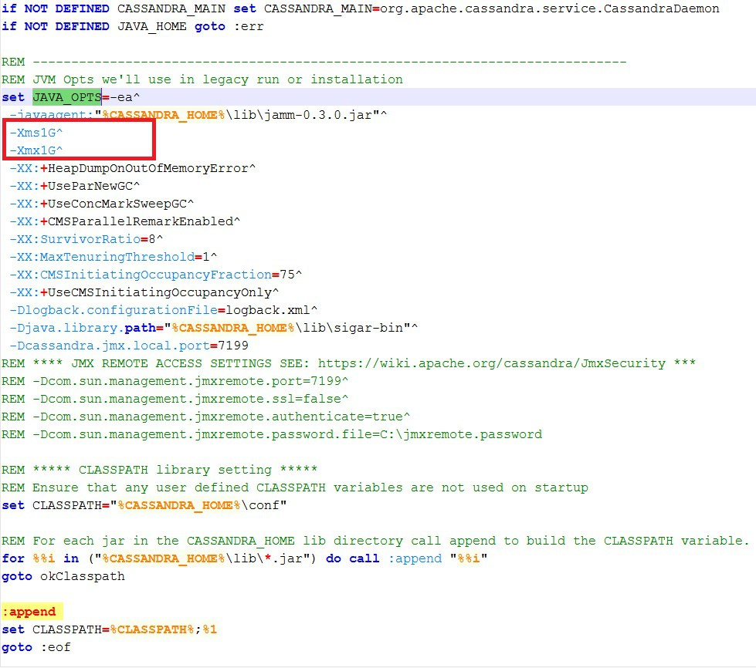](https://i0.wp.com/developertutorials.net/wp-content/uploads/2016/09/java_opts.jpg)

Step 5:

Start Cassandra server by navigating to below path and execute Cassandra.bat  
<Cassandra_folder>\apache-cassandra-3.7\bin\Cassandra.bat  
Once the server is started without errors you can see the message on the console as :

*Starting listening for CQL clients on localhost/127.0.0.1:9042*

[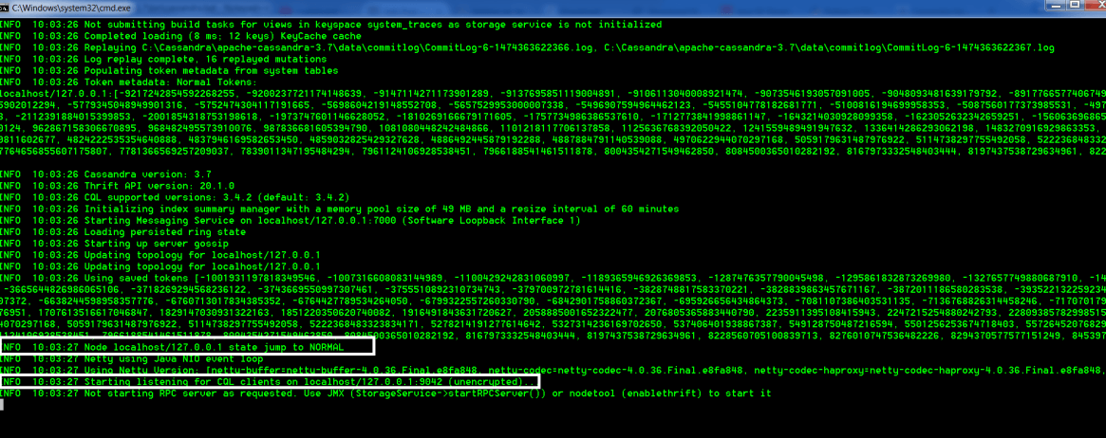](https://i0.wp.com/developertutorials.net/wp-content/uploads/2016/09/cassandra-server-start.png)

cassandra server start

You can launch CQL by clicking cqlsh.bat in bin folder.

[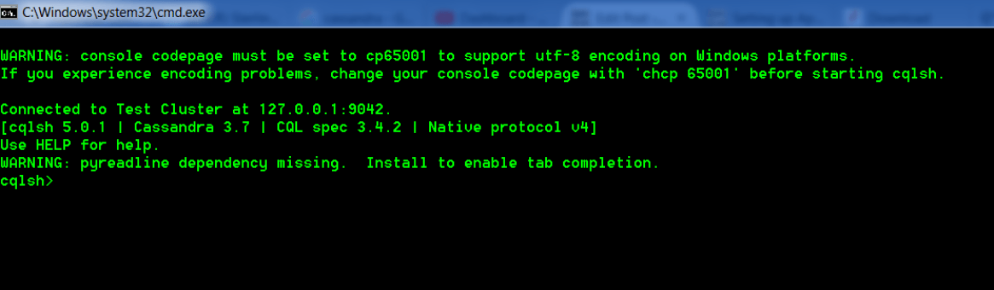](https://i2.wp.com/developertutorials.net/wp-content/uploads/2016/09/cqlsh.png)

cqlsh